REAL TIME LICENSE PLATE DETECTION USING
MACHINE LEARNING
A MINI PROJECT REPORT
Submitted by
P. ISHWARIYA 412818205021
R.LAKSHMI PRABHA 412818205034
P.V. MYTHIREYENI 412818205042
M. NEELAVENI 412818205045



SRM VALLIAMMAI ENGINEERING COLLEGE
(AN AUTONOMOUS INSTITUTION)
DEPARTMENT OF INFORMATION TECHNOLOGY
SRM NAGAR, KATTANKULATHUR, KANCHEEPURAM
ANNA UNIVERSITY: CHENNAI 600 025
MARCH 2021

BONAFIDE CERTIFICATE

Certified that this project report “REAL TIME LICENSE PLATE DETECTION USING MACHINE LEARNING” is the bonafide work of “P. ISHWARIYA (412818205021), R. LAKSHMI PRABHA (412818205034), P.V. MYTHIREYENI (412818205042) and M. NEELAVENI (412818205045)” who carried out the project work under my supervision.
SIGNATURE | SIGNATURE
Dr. A. R. REVATHI | Dr. A. R. REVATHI
HEAD OF THE DEPARTMENT | SUPERVISOR
Associate Professor | Associate Professor
SRM Valliammai Engineering College | SRM Valliammai Engineering College
(An Autonomous Institution) | (An Autonomous Institution)
SRM Nagar, Kattankulathur,  Chengalpattu – 603203 | SRM Nagar, Kattankulathur,  Chengalpattu - 603203

ACKNOWLEDGEMENT

First and foremost, we would like to extend our heartfelt respect and gratitude to Management, Principal Dr. B. Chidhambara Rajan, M.E., Ph.D., and Vice Principal Dr. M. Murugan, M.E., Ph.D., who helped us in our endeavors.
We also extend our heartfelt respect to our beloved Head of the Department and our project guide Dr. A. R. Revathi, B.E., M.Tech., M.B.A., Ph.D. Associate Professor for offering her sincere support throughout the project work.
We thank our Project Co-Ordinator(s) Dr.S.Narayanan. B.E., M.Tech.,Ph.D. Assistant professor (SelectionGrade),Ms.R.Thenmozhi, M.Tech., (Ph.D) Assistant Professor (Selection Grade), Ms.R.Saranya, M.Tech., Assistant Professor (Ordinary Grade) and Mr.R.Sankaranarayanan M.E., Assistant Professor (Ordinary Grade) for their consistent guidance and encouragement throughout the progress of the project.
We would also thank all the Teaching and Non-Teaching staff members of our department for their constant support and encouragement throughout the course of this project work.
Finally, the constant support from our lovable Parents and Friends is untold and immeasurable.

ABSTRACT
A license plate detection system is an important tool in several roadway traffic applications to develop an advanced detection system that works well in complicated scenarios. Robust preprocessing enhancement method is used for accurately detecting the license plates from difficult vehicle images and includes the combination of a Gaussian filter, an enhancement cumulative histogram equalization method, and a contrast-limited adaptive histogram equalization technique. The Local Binary Pattern and median filter with Histogram of Oriented Gradient descriptors are used as powerful tools to extract key features from three types of license plate resolutions. The extracted features are used as input to Support Vector Machine (SVM) classifier. Processing methods, such as a position-based method are used with the detector to reduce unwanted bounding boxes, as well as false positive values. Four databases consisting of 2050 vehicle images under different conditions are used. Various detection metrics, object localization, and the Receiver Operating Characteristic (ROC) curve are used to evaluate the performance of the proposed method. The detection rate when trained with 1520 LP images is 99.62% with a false positive rate of 1.675% for complicated images. The average detection time per vehicle image is 0.2408 milliseconds.
Keywords - Histogram of Oriented Gradient, License Plate Detection, Local Binary Patterns, Support Vector Machine.

TABLE OF CONTENTS
CHAPTER NO. | TITLE | PAGE NO.
 | ABSTRACT | i
1. | INTRODUCTION | 6
 | 1.1 Overview | 7
 | 1.2 Objective | 8
 | 1.3 Challenges  1.4 Advantages | 8
2. | LITERATURE SURVEY | 9
 | 2.1 Literature Survey | 10
 | 2.2 Summary | 11
3. | SYSTEM ANALYSIS AND DESIGN | 15
 | 3.1 Existing System  3.1.1 Limitations | 16  16
 | 3.2 Proposed System  3.3 Architecture Diagram | 17  18
4. | REQUIREMENTS SPECIFICATION | 21
 | 4.1 Software Requirements | 22
 | 4.2 Hardware Requirements | 23
5. | CONCLUSION  REFERENCES | 24  26

CHAPTER 1

INTRODUCTION

1. INTRODUCTION
1.1 OVERVIEW
Automatic number plate recognition (ANPR) systems have become a very important tool in many surveilling applications over the past few decades. They are often used as a surveillance technique to identify license plates of vehicles and are very useful for security systems, highway road tolling systems, traffic sign systems, tracking, and parking management systems. The existing systems often work under some standard conditions, such as low-high lighting, rain, and limited day-night lighting. It is still very challenging to identify license plates (LPs) from complicated vehicle images because of environmental effects. A robust license plate detection (LPD) system is desirable to effectively work under all sorts of difficult conditions, such as night, dusk, rain, fog or snow; with images that are blurred, rotated, low-high lighting, distorted, with complex backgrounds and different colors.
1.2 OBJECTIVES
The license plate detection using machine learning will make an effective and reliable detection rate above 99.62% by using precision recall parameters. To achieve False Positive Rate of 1.675% for complicated images with complex backgrounds, blurred images, License plate less vehicle images etc. achieve the accuracy Histogram of oriented gradients, Local binary pattern, Support vector machine and Extreme learning machine algorithms are used. The English car database holds 510 images of License plate under different resolutions and different conditions such as too dark, blurry distortion, and low/high contrast environments to get the accuracy.
1.3 CHALLENGES
The effectiveness of the existing system was confirmed to yield a license plate detection rate of approximately 90%.The false positive rate for complicated images is 1.675%. The angle of camera and the distance constraints make a License plate detection system less robust.
    - ADVANTAGES
The accuracy is maintained, which confirms to yield a license plate detection rate of approximately 99%. The Time efficiency is increased. A robust license plate detection (LPD) system is desirable to effectively work under all sorts of difficult conditions, such as night,dust,rain,fog or snow.

CHAPTER 2

LITERATURE SURVEY
2.1 LITERATURE SURVEY:
Various articles and articles must be surveyed in order to create a software application that has never been applied before. Various publications, journals, and documents have been referred to in this section, and the suggested approach has been studied and outlined below.
[1]. Imam Taufiq, Dr. Bambang Purnomosidi, M. Agung Nugroho and Akhmad Dahlan, (2018), “Real-time Vehicle License Plate Detection by Using Convolutional Neural Network Algorithm with Tensorflow”. IEEE Access.
The paper proposed vehicle license plates detection system by using convolutional neural network (CNN) with tensorflow. The research was conduct in three step process such as data pre-processing, training/testing process, and interpretation result. Using CNNs algorithm in tensorflow with 25,000 steps and 8 batches on the training process can produce a training model of vehicle license plates detection with high accuracy around 70-99%.

[2]. Shigeharu Miyata, (2016),”Automated License Plate Detection Using A Support Vector Machine”. In this paper it uses SVM (Support Vector Machine) based on negative and positive examples is used to determine whether or not a candidate area is a license plate. IEEE Access.
The paper proposes a new method of detecting license plates in images of vehicles where the license plate is shown, and reports the detection results when the method was applied to detection of license plates on vehicles in Japan. This license plate detection process detects only the edge vertical components, and the candidate license plates are narrowed down using the contours obtained by dilation and erosion processing and region fill processing. A SVM (Support Vector Machine) based on negative and positive examples is used to determine whether or not a candidate area is a license plate, and finally the position of the license plate is identified. This study examined how the license plate detection results in license plate and non-license plate images were affected by differences in aspect ratios, differences in brightness between the vehicle body and license plate, and the number of positive and negative examples used for learning. The effectiveness of this method was confirmed to yield a license plate detection rate of approximately 90%.

[3]. Rahul R. Palekar, Sushant U. Parab and Dhurmil P. Parikh, 2017,”Real Time License Plate Detection Using OpenCV and Tesseract”. IEEE Access.
The concept proposes a new method of detecting license plates in images of vehicles where the license plate is shown, and reports the detection results when this method was applied to detection of license plates on vehicles in Japan. This license plate detection process detects only the edge vertical components, and the candidate license plates are narrowed down using the contours obtained by dilation and erosion processing and region fill processing. A SVM (Support Vector Machine) based on negative and positive examples is used to determine whether or not a candidate area is a license plate, and finally the position of the license plate is identified. This study examined how the license plate detection results in license plate and non-license plate images were affected by differences in aspect ratios, differences in brightness between the vehicle body and license plate, and the number of positive and negative examples used for learning. The effectiveness of this method was confirmed to yield a license plate detection rate of approximately 90%.

2.2 SUMMARY
S.No. | Year | Paper name | Title of the paper | concept | Challenges
01 | 2018 | 2nd Borneo International Conference on Applied Mathematics and Engineering | Real time vehicle license plate detection by using convolutional neural network algorithm with tensor flow | It propose vehicle license plates detection system  by using convolutional neural network (CNN) with tensor flow | This have the accuracy around 70-99%
02 | 2017 | International conference on Communication and Signal Processing | Real Time License Plate Detection Using  OpenCV and Tesseract | The  CV2 OpenCV library using Python language is used for image  processing and Tesseract is used for text extraction from the  processed image | This have the accuracy around 89%
03 | 2016 | 14th International conference on Control Automation,Robotics and Vision | Automated license plate detection using a support vector machine | SVM (Support Vector Machine) based on negative  and positive examples is used to determine whether or not a candidate area is a license plate | The effectiveness of this method was confirmed to yield a license plate  Detection rate of approximately 90%.

CHAPTER – III
SYSTEM DESIGN AND ANALYSIS

3.1 EXISTING SYSTEM
The performances are reported by a genetic algorithm depending on the HOG features with a mixture of binary classifiers to classify LP and non-LP images. The genetic algorithm was applied to select the best features subset for improving the classification performance. The method used a mixture of binary classifiers of k-nearest neighbor, SVM, decision tree, and linear discriminant analysis.
    - LIMITATIONS
The Support Vector Machine (SVM) required a high-contrast preprocessing method to improve images. SVM method also leads to increase false positive rate. The effectiveness of SVM method was confirmed to yield a detection rate of approximately 90%
  - PROPOSED SYSTEM
Algorithms which are used are, HOG- histogram of oriented gradients, LPB- local binary pattern, Feature selection using SVM (support vector machine) and ELM (extreme learning machine) classifiers and also it is implemented using tensor flow and Tesseract python libraries.An English car database including 510 vehicle images under different conditions. The LPD system the extended database also includes the rotated images with different LP angles, such as 45◦, 30◦, 20◦, 15◦, and 5◦. The dataset contains various illumination conditions with three LPs resolutions of 100 × 25, 200 × 50 and 300 x 75.
  - ARCHITECTURE DIAGRAM
The architecture diagram consists of a dataset known as ENGLISH CAR DATABASE which holds nearly 500 images of license plates. The image is processed and led to the segmentation process using HOG. The image is then sent to testing or training phase. The image is converted into Grey scale and Gaussian filter is applied for feature extraction
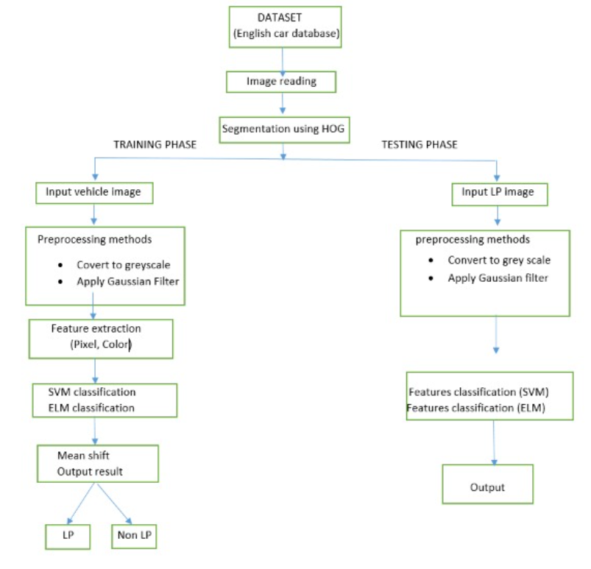
ARCHITECTURE DIAGRAM FOR TRAINING AND TESTING PHASE

METHODOLOGY
The structural diagram of the proposed LPD methodology. It consists of two stages: training and testing. The training stage employs SVM and ELM learning algorithms, separately. Both training and testing phases use the same pre-processing and extraction methods. At the pre-processing techniques are applied to enhance the problematic part of vehicles images, while keeping the quality of the normal images during the enhancement process. Through the feature extraction stage, this study carefully selects the effective descriptors, MHOG and LBP, which are suitable for difficult conditions such as under low/high contrast, dirt, dusk, fog, and distortion problems. Finally, the detection stage uses a SVM and an ELM classifier, separately, as trained models to detect the LP region from the tested input vehicle image. The TRUE POSITIVE output results are saved for the recognition stage to obtain a complete ANP
- Histogram of Oriented Gradients (HOG)
The histogram of oriented gradients (HOG) is a feature descriptor used in computer vision and image processing for the purpose of object detection. The technique counts occurrences of gradient orientation in localized portions of an image. This method is similar to that of edge orientation histograms, scale-invariant feature transform descriptors, and shape contexts, but differs in that it is computed on a dense grid of uniformly spaced cells and uses overlapping local contrast normalization for improved accuracy
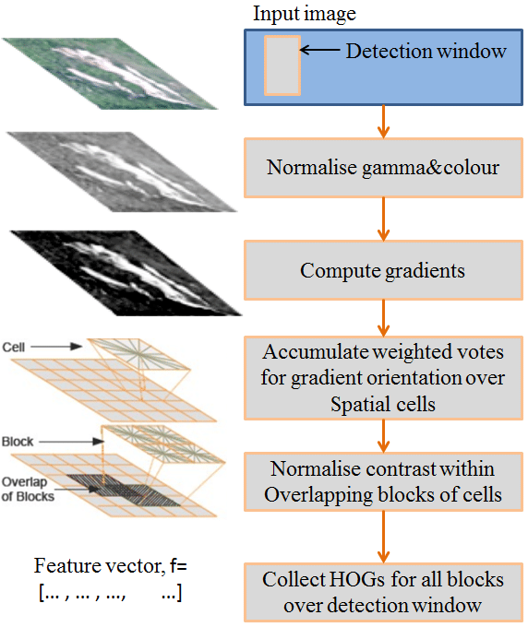
Fig3.3.1 Histogram of Oriented Gradients

- Support Vector Machine (SVM)
Support Vector Machine or SVM is one of the most popular Supervised Learning algorithms, which is used for Classification as well as Regression problems. However, primarily, it is used for Classification problems in Machine Learning. The goal of the SVM algorithm is to create the best line or decision boundary that can segregate n-dimensional space into classes so that we can easily put the new data point in the correct category in the future. This best decision boundary is called a hyper plane. SVM chooses the extreme points/vectors that help in creating the hyper plane. These extreme cases are called as support vectors, and hence algorithm is termed as Support Vector Machine. Consider the below diagram in which there are two different categories that are classified using a decision boundary or hyper plane.

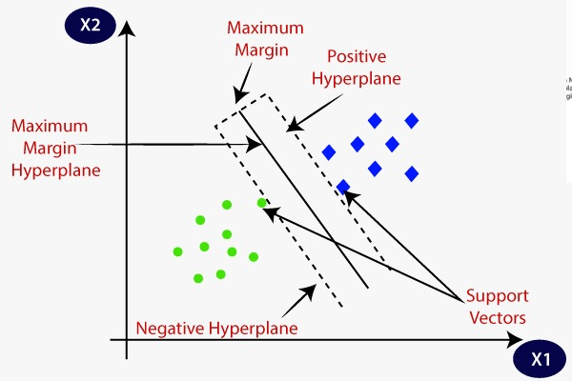
Fig3.3.2 Support Vector Machine

- Extreme Learning Machine (ELM)
Extreme learning machines are feed forward neural networks for classification, regression, clustering, sparse approximation, compression and feature learning with a single layer or multiple layers of hidden nodes, where the parameters of hidden nodes (not just the weights connecting inputs to hidden nodes) need not be tuned. These hidden nodes can be randomly assigned and never updated (i.e. they are random projection but with nonlinear transforms), or can be inherited from their ancestors without being changed. In most cases, the output weights of hidden nodes are usually learned in a single step, which essentially amounts to learning a linear model. The name "extreme learning machine" (ELM) was given to such models by its main inventor Guang-Bin Huang. According to their creators, these models are able to produce good generalization performance and learn thousands of times faster than networks trained using back propagation.[1] In literature, it also shows that these models can perform support vector machines in both classification and regression applications.

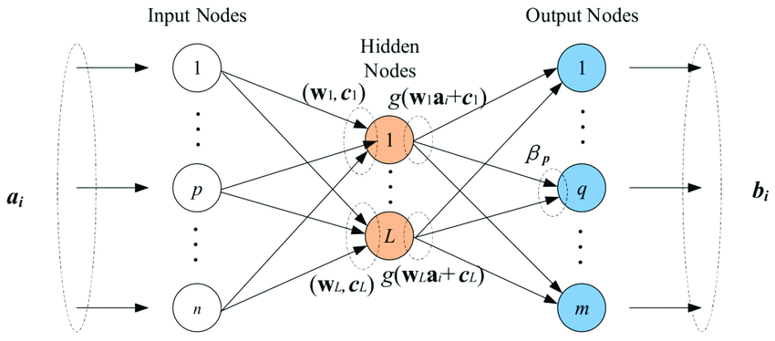
Fig3.3.3 Extreme Learning Machine
- Local Binary Pattern (LBP)
Local Binary Pattern (LBP) is a simple yet very efficient texture operator which labels the pixels of an image by thresholding the neighborhood of each pixel and considers the result as a binary number. It was first described in 1994 (LBP) and has since been found to be a powerful feature for texture classification. It has further been determined that when LBP is combined with histograms of oriented gradients (HOG) descriptor, it improves the detection performance considerably on some datasets. Using the LBP combined with histograms we can represent the face images with a simple data vector.
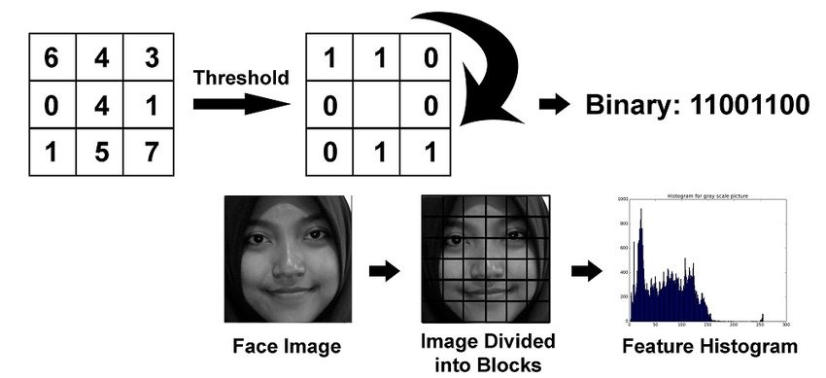

Fig3.3.4 Local binary pattern

CHAPTER – IV
REQUIREMENTS
SPECIFICATION

4. REQUIREMENTS
4.1 SOFTWARE REQUIREMENTS
- ANACONDA IDE
Anaconda is a distribution of the Python and R programming languages for scientific computing (data science, machine learning applications, large-scale data processing, predictive analytics, etc.), that aims to simplify package management and deployment. The distribution includes data-science packages suitable for Windows, Linux, and macOS. It is developed and maintained by Anaconda, Inc., which was founded by Peter Wang and Travis Oliphant in 2012. As an Anaconda, Inc. product, it is also known as Anaconda Distribution or Anaconda Individual Edition, while other products from the company are Anaconda Team Edition and Anaconda Enterprise Edition, both of which are not free. Package versions in Anaconda are managed by the package management system conda. This package manager was spun out as a separate open-source package as it ended up being useful on its own and for other things than Python. There is also a small, bootstrap version of Anaconda called Miniconda, which includes only conda, Python, the packages they depend on, and a small number of other packages.
B. Python
Python is a widely used high-level, general-purpose,interpreted, dynamic programming language. Its design philosophy emphasizes code readability, and its syntax allows programmers to express concepts in fewer lines of code than would be possible in languages such as C++ or Java. The language provides constructs intended to enable clear programs on both a small and large scale. Python supports multiple programming paradigms, including object-oriented, imperative and functional programming or procedural styles. It features a dynamic type system and automatic memory management and has a large and comprehensive standard library.
Python programming language made us enable to write short code snippets for each processing techniques. It also enabled us to develop a multi-level processing mechanism. Thus python programming language was indeed very helpful in the digital processing of the stock images by writing simple and easily understandable python codes.
C. Tesseract
Python-tesseract is an optical character recognition (OCR) tool for python. That is, it will recognize and “read” the text embedded in images.
Python-tesseract is a wrapper for Google’s Tesseract-OCR Engine. It is also useful as a stand-alone invocation script to tesseract, as it can read all image types supported by the Pillow and Lepontic imaging libraries, including jpeg, png, gif, bmp, tiff, and others. Additionally, if used as a script, Python-tesseract will print the recognized text instead of writing it to a file.
D. Tensor Flow
It is an open-source library developed by Google primarily for deep learning applications. It also supports traditional machine learning.
Tensor Flow was originally developed for large numerical computations
PARAMETERS FOR ANALYSIS
PRECISION RECALL PARAMETER
Precision-Recall is a useful measure of success of prediction when the classes are very imbalanced. In information retrieval, precision is a measure of result relevancy, while recall is a measure of how many truly relevant results are returned.The precision-recall curve shows the tradeoff between precision and recall for different threshold. A high area under the curve represents both high recall and high precision, where high precision relates to a low false positive rate, and high recall relates to a low false negative rate. High scores for both show that the classifier is returning accurate results (high precision), as well as returning a majority of all positive results (high recall).A system with high recall but low precision returns many results, but most of its predicted labels are incorrect when compared to the training labels. A system with high precision but low recall is just the opposite, returning very few results, but most of its predicted labels are correct when compared to the training labels.
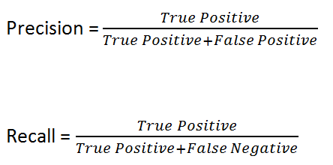
TRUE POSITIVE
A True positive is an outcome where the model correctly predicts the positive class.
True positive = (TruePositive/TruePositive+FalseNegative)
TRUE NEGATIVE
A true negative is an outcome where the model correctly predicts the negative class.
True negative = (True positive /True Positive+FalseNegative)
FALSE POSITIVE
A false positive is an outcome where the model incorrectly predicts the positive class.
False positive= (FalsePositive/FalsePositive+TrueNegative)
FALSE NEGATIVE
A false negative is an outcome where the model incorrectly predicts the negative class.
False negative= (FalseNegative/FalseNegative+Truespositive)

4.2 HARDWARE REQUIREMENTS
- PROCESSOR : CORE i5
- RAM : 4 GB (Minimum)
- HARD DISK DRIVE : (250GB minimum)
- Camera:16 megapixel (if required)

CHAPTER V
CONCLUSION
5.1 CONCLUSION
The study proposed a new pre-processing method to improve the LPD system performance for complicated vehicle images by a Gaussian filter and the image processing techniques. The HOG and LBP descriptors were used to extract the representative LP features. The English car plates’ database, uses English language vehicles images databases were used to evaluate the system performance under more difficult and complicated image conditions. The proposed method was tested using different databases with simple and complicated conditions, such as fogy, low/high contrast, distorted and rotated LPs. It yielded excellent results. The detection and accuracy rates are 99.62% and 98.12%, respectively. The average runtime for the detection stage per vehicle image was 0.2408ms. The experimental results demonstrated that the proposed technique could be applied efficiently for real-time applications.

REFERENCES

REFERENCES

[1] Meeras Salman Al-Shemarry, and Yan li,Sept 2020,”Developing Learning-Based Preprocessing Methods for Detecting Complicated Vehicle Licence Plates”, This work is licensed under a Creative Commons Attribution 4.0 License. VOLUME 8, pp. 170951-170966.
[2] Imam Taufiq, Dr. Bambang Purnomosidi, M. Agung Nugroho and Akhmad Dahlan, 2018, “Real-time Vehicle License Plate Detection by Using Convolutional Neural Network Algorithm with Tensorflow”, 2nd Borneo International Conference on Applied Mathematics and Engineering (BICAME).
[3] Shigeharu Miyata, 2016,”Automated License Plate Detection Using a Support Vector Machine”, 14th international Conference on Control Automation and Robotics & Vision Phuket.
[4] Rahul R. Palekar, Sushant U. Parab and Dhurmil P. Parikh, 2017,”Real Time License Plate Detection Using OpenCV and Tesseract”,International Conference On Communication And Signal Processing.

